*Florida International University*

*School of Computing and Information Sciences*

Software Engineering Focus

Final Deliverable

Project Title:

**Life Management 1.0**

**Team Members: Beatriz Hernandez, Fernando Mojena Amaya**

**Product Owner(s)**: Ranjeet Deshmukh

**Mentor(s)**:

**Instructor**: Masoud Sadjadi

The MIT License (MIT)

Copyright (c) *2016 Florida International University*

Permission is hereby granted, free of charge, to any person obtaining a copy of this software and associated documentation files (the "Software"), to deal in the Software without restriction, including without limitation the rights to use, copy, modify, merge, publish, distribute, sublicense, and/or sell copies of the Software, and to permit persons to whom the Software is furnished to do so, subject to the following conditions:

The above copyright notice and this permission notice shall be included in all copies or substantial portions of the Software.

THE SOFTWARE IS PROVIDED "AS IS", WITHOUT WARRANTY OF ANY KIND, EXPRESS OR IMPLIED, INCLUDING BUT NOT LIMITED TO THE WARRANTIES OF MERCHANTABILITY, FITNESS FOR A PARTICULAR PURPOSE AND NONINFRINGEMENT. IN NO EVENT SHALL THE AUTHORS OR COPYRIGHT HOLDERS BE LIABLE FOR ANY CLAIM, DAMAGES OR OTHER LIABILITY, WHETHER IN AN ACTION OF CONTRACT, TORT OR OTHERWISE, ARISING FROM, OUT OF OR IN CONNECTION WITH THE SOFTWARE OR THE USE OR OTHER DEALINGS IN THE SOFTWARE.

***Abstract***

*This document presents the information necessary to gain a good understanding of the Life Management System. This solution will provide a way for users to simplify their life by keeping track of their daily activities and how they tie to their overall vision of life.* *The technologies used include ASP.NET using Model-View-Controller (MVC), C# as server side language, SQL Server for as DBMS, and a collection of frameworks for front end design, including bootstrap and jquery among others.*

**Table of Contents**

**Introduction** …………………………………………………………………………………………………………………………….. 5

Current System ……….…………………………………………………………………………………………………………... 5

**User Stories**

Implemented User Stories ………………………………………….………………………………………………………..6

Pending User Stories …………………………………………………………………...………………………………..….. 18

**Project Plan**

Hardware and Software Resources ……………………………………………………...……………………….… 19

Sprints Plan ……………………………………………………………..………………………………………………………. 19

*Sprint 1*  …………………………………………………………………………………………………………………………... 19

*Sprint 2*  …………………………………………………………………………………………………………………………... 20

*Sprint 3*  …………………………………………………………………………………………………………………………... 22

*Sprint 4*  …………………………………………………………………………………………………………………………... 24

*Sprint 5*  …………………………………………………………………………………………………………………………... 25

**System Design**

Architectural and design Patterns ……………………………………………………………………………….. 25

System and Subsystem Decomposition ………………………………………………………………….……….… 26

Class Diagram …………………………………………………………………………………………………….………….... 28

**System Validation**  …………………………………………………………………………………………………………………….29

**Glossary**  ………………………………………………………………………………………………………………………………….30

**Appendix**  ………………………………………………………………………………………………………………………………….31

Appendix A - UML Diagrams ………………………………………………………………………………………………. 31

*Static UML Diagrams*  ……………………………………………………………………………………………………….31

*Dynamic UML Diagrams*  …………………………………………………………………………………………………..33

Appendix B - Sprint Review Reports …………………………………………………………………………...…… 49

Appendix C - User Manuals, Installation/Maintenance Document, Shortcomings/Wishlist Document and other documents …………………………………………………………………….………………... 53

**References** ……………………………………………………………………………………………………………………...………...66

# 

# 

# Introduction

Most people lack a sense of fulfillment and purpose in their lives. The increased use of technology, especially social media has added multiple distractions across all age groups. At times, the continued use of social media provides an escape from reality. Hence, most people end up spending time on things that do not matter leaving them with a feeling of emptiness and dissatisfaction. Therefore, The Life Management arises as a need to help people find their purpose, and provide them with a simple, yet intuitive and efficient way to get through Life’s challenges in a simple, yet fun and engaging manner.

To sum up, the Life management platform will help user’s identity their life’s priorities, align them with their vision and help them visualize their growth giving them a sense of fulfillment and self-confidence. The platform will tie this together in a system consisting of coaches that will help users reach their goals in the smartest and quickest manner possible. The Life Management helps you discover what matters to you and builds your own personalized life management system while connecting you with folks who care about your progress.

## Current System

This is the first version of the product, and it consist of the following parts. First, users will need to fill out a quick questionnaire that helps them find out what they want in life through a compelling vision and a set of matching activities that tie to their vision. Then, they will be able to visualize their progress in real time, by keeping track of the activities they perform in their dashboard. Finally, the application provides a social platform that helps users connect with mentors that can guide them through their journey.

## 

# User Stories

The following section provides the detailed user stories that were implemented in this iteration of the Life Management project. These user stories served as the basis for the implementation of the project’s features. This section also shows the user stories that are to be considered for future development.

## Implemented User Stories

**User Story Name:** Main Page

### Description:

* + As a guest user I should see a main page when I navigate to the site url so I can see general information about the site.

### Acceptance Criteria:

* A main page is presented when navigating to the site url.

**User Story Name:** Login Page

### Description:

* As any user I should be able to see a login link that takes me to a login page so I can later login in the website.

### Acceptance Criteria:

* There exists a login link available throughout the website
* clicking the login link displays a login page

**User Story Name:** SeeSite Admin Dashboard

### Description:

* As a Site Admin i would like to see a page where I can manage categories, activities, users and roles.

**Acceptance Criteria:**

1. There exists an Admin Dashboard page

**User Story Name:** Login

### Description:

* As a registered user, I should be able to login and be presented with my dashboard page so I can continue to make progress in my life management. I should be displayed error messages incorrect login info is entered so as to inform me of the bad input.

### Acceptance Criteria:

* Registered user is able to login
* Dashboard page is presented after login
* Error messages display when incorrect login info is input

**User Story Name:** Sign Up

**Description:**

* As a guest user, I should be able to sign up in the site with basic personal information so I can use it further and a confirmation of registration should appear so I am confident my information was saved. On signup success I would like to start the questionnaire to complete my profile.

**Acceptance Criteria**

* Guest User is able to sign up in the site and confirmation is shown.
* Show error when bad input.
* Show Start Questionnaire page when successfully signed up

**User Story Name:** Reset Password

**Description:**

* As a registered user, I should be able to reset my password in case I forgot it. I would receive an email with a link to reset my password. I should follow the link and fill in the info to reset my password.

**Acceptance Criteria:**

1. User follows the link on their email and is redirected to the correct page to reset their password.
2. The user changes their password and is able to login with the new password.

**User Story Name:** Collect Joy

### Description:

* As a registered user, I will be presented with several options in the joy section of the questionnaire. I will be able to pick 3 activities so I can setup a sprint. Once I select those activities, the Giving back section is presented.

**Acceptance Criteria:**

* A page with a list of joy activities is displayed.
* Three activities must be picked and saved for this sprint.
* The Giving back section of the questionnaire is presented when user is done with the Joy section.

**User Story Name:** Collect Passion

### Description:

* As a registered user, I will be presented with several options in the passion section of the questionnaire. I will be able to pick 2 activities. Once I select those activities, the Giving back section is presented.

### Acceptance Criteria:

* A page with a list of Passion activities is displayed.
* Two activities must be picked and saved for this sprint.
* The Giving back section of the questionnaire is presented when user is done with the Passion section.

**User Story Name:** Collect Giving Back

### Description:

* As a registered user, I will be presented with several options in the Giving Back section of the questionnaire. I will be able to pick 2 activities. Once I select those activities, my dashboard will be presented.

### Acceptance Criteria:

1. A page with a list of Giving back activities is displayed.
2. Two activities must be picked.
3. The User Dashboard is presented once the user finishes with their selections.

**User Story Name:**  Setting Up vision Goal

### Description:

* As a new registered user, I should be able to answer a questionnaire that helps me set up my goals in life.

### Acceptance Criteria:

1. User is redirected from sign up page to this questionnaire.
2. The questionnaire should provide hints that help users elaborate their goals.
3. All data entered by the user should be stored.

**User Story Name:** SeeDashboard Page Joy Tab

### Description:

* As an authenticated user I want to update my activities related to Joy so that statistics reflect my progress.

### Acceptance Criteria:

1. In the dashboard page, current Sprint and statistics are displayed related to Joy.
2. User is able to update progress related to Joy.
3. Statistical information is updated.

**User Story Name:** SeeDashboard Page Passion Tab

### Description:

* As an authenticated user I want to update my activities related to Passion so that statistics reflect my progress.

**Acceptance Criteria:**

1. In the dashboard page, current Sprint and statistics are displayed related to Passion.
2. User is able to update progress related to Passion.
3. Statistical information is updated.

**User Story Name:** SeeDashboard Page Giving Back Tab

### Description:

* As an authenticated user I want to update my activities related to Giving back so that statistics reflect my progress.

### Acceptance Criteria:

1. In the dashboard page, current Sprint and statistics are displayed related to Giving Back
2. User is able to update progress related to Giving Back
3. Statistical information is updated.

**User Story Name:** Summarize Sprint Score

### Description:

* As an authenticated user I want to see a Score Summary page so that I can have an overview of my progress.

### Acceptance Criteria:

1. A score summary page is displayed with relevant statistics.

**User Story Name:** Add Life Coach

### Description:

* As a site administrator I should be able to add a new Life Coach so they can start coaching Users.

### Acceptance Criteria:

1. Admin can add a life coach.
2. A coach can start using the system immediately.

**User Story Name:** Create an Activity

### Description:

* As an admin I can create a new activity, by entering a name, picture and category. After creation, this activity becomes available to the rest of the users so they can use them to specify their sprint activities.

### Acceptance Criteria:

1. From the dashboard, the admin will follow a link to a form.
2. After completing filling out the form a new activity should be created and available to all users.

**User Story Name:** New Sprint Setup

### Description:

* As a User I should be notified when my productivity week has ended so that I can start a new one using my previous configuration, or editing each component as desired.

**Acceptance Criteria:**

1. A notification shows up in the user’s dashboard when the user logs-in after the last day their previous sprint has ended.
2. The system should facilitates the configuration of the new sprint by providing the last period’s configuration.
3. After configuring the new sprint the user should be redirected to the dashboard and their new sprint should now be available.

**User Story Name:** Edit an Activity

### Description:

* As an admin I can edit an activity, by selecting it from its category, and should be to change its name, picture or category.

### Acceptance Criteria:

1. From the dashboard, the admin will follow a link to the edit form.
2. After selecting the activity, an admin should be able to change any field.
3. The changes should be stored accordingly.

**User Story Name:** Edit Life Coach

### Description:

* As an Admin I should be able to edit the personal information of a life coach, so that it is correct and up to day.

### Acceptance Criteria:

1. Changes made to a life coach’s information should become available immediately.
2. Data must preserve integrity.

**User Story Name:** Remove Life Coach

### Description:

* As an admin I should be able to remove a Life Coach from the system.

### Acceptance Criteria:

1. The coach has no longer access to the system.

**User Story Name:** Share Progress

### Description:

* As an authenticated user I should be able to share my progress with a coach of my preference, so that I can start receiving feedback and guidance from them.

### Acceptance Criteria:

1. User is able to share their progress with a Life Coach via email.
2. User should be notified if the sharing was successful.

**User Story Name:** See Life Coaches

### Description:

* As a user or a guest, I want to see a list of Life Coaches so that I can decide which one to select as a life coach.

### Acceptance Criteria:

1. There exists a page displaying life coaches with reviews and descriptions available to guest users.
2. Coaches can be seen from the user dashboard.

**User Story Name:** Details Page of Coach

### Description:

* As an User I should be able to see detail information of a certain Coach, so that I can decide if that coach is the right for me.

### Acceptance Criteria:

1. The information of the coach is presented clearly in the Coach Details page.

**User Story Name:** Login Coach

### Description:

* As a Coach I should be able to have a separate login page so that I can access my dashboard and start using the system.

### Acceptance Criteria:

1. Coaches are able to enter their accounts using a separated path than regular users.
2. Roles are well differentiated.

**User Story Name:** Reset Password

### Description:

* As a coach I should be able to reset my password, so that I can regain access to my account in case I forget my password.

**Acceptance Criteria:**

1. The recovery information should be sent to the coach email address registered in the system.
2. The system should inform if the email address entered is not recognized.
3. The coach should be able to login the system using their new password.

**User Story Name:** See Coach Dashboard

### Description:

* As a coach I want to have a dashboard so that I can easily interact with users.

### Acceptance Criteria:

1. There exists a dashboard for coaches.
2. There is a chat where users are displayed.
3. Coaches can send messages to users.

**User Story Name:** Communicate With Life Coach

### Description:

* As a user I want to communicate and share files with my life coach so that to I can receive feedback and guidance from coach.

**Acceptance Criteria:**

1. There exists a Chat where coaches can be selected.
2. User can send messages to coach.
3. User can upload files to chat.

**User Story Name:** Review Coach

### Description:

* As a registered user I want review my coach so that other users will be informed of my thoughts about my life coach.

### Acceptance Criteria:

1. User is able to create a review for selected coach.
2. Review is sent to Site admins for approval.

**User Story Name:** Check Coach Review

### Description:

* As a Site Admin I want to check and approve/reject Coaches reviews so that users will be able to see approved coaches reviews

### Acceptance Criteria:

1. Site admin is able to see pending reviews.
2. Site admin is able to approve reviews and as a result, review is posted in coach page and reviewer is notified.
3. Site admin is able to reject a review and such review is not posted.

**User Story Name:** Add Activity

### Description:

* As a user I want to add an activity so that I can specifically represent what I will do in my sprint.

**Acceptance Criteria:**

1. There is an add activity option when selecting activities.

**User Story Name:** Delete Activity

### Description:

* As a Site Admin I should be able to delete an Activity from the Site so that no obsolete Activity remains in the system.

**Acceptance Criteria:**

1. System Admin can delete an activity, if it is not being used for any User.
2. Changes are available immediately.

**User Story Name:** Take coaching quiz

### Description:

* As a user or guest I should be able to take a quiz so that I can decide whether I need a life coach in my life or not.

### Acceptance Criteria:

1. There exists a quiz link in menu for guests.
2. There exists a quiz link in dashboard for users.
3. The quiz will take answers from users and give appropriate score.

**User Story Name:** Manage Account

### Description:

* As an authenticated user I should be able to manage my account so that my personal information remains up to date.

### Acceptance Criteria:

1. User is able to see their personal information and update it.
2. The updated information is stored accordingly.
3. Changes are available immediately.

**User Story Name:** Create Crud for Roles

### Description:

* As a Site Admin I should be able to manage Roles in the Site so that I can keep permissions updated.

### Acceptance Criteria:

1. Site Admin can add a Role.
2. Site Admin can see a list of Roles.
3. Site Admin can delete a Role if no user has such role.
4. Site Admin can edit a Role.

**User Story Name:** Create Crud for Users

### Description:

* As a Site Admin I should be able to manage User accounts in the system, so that I can keep track of their personal information and/or remove the account when needed.

**Acceptance Criteria:**

1. Site Admin can see a list of all Users in the system.
2. Site Admin can see detailed information of the users.
3. Site Admin can delete an User account if violates the terms and conditions.

**User Story Name:** Invite to App

### Description:

* As a registered User I should be able to invite friends to this site, so that they can start using the system as well.

### Acceptance Criteria:

1. User can enter an email address of the friend they want to invite and the system should send them a link to the Sign-up page.

## Pending User Stories

There were not pending stories for this release, but the system can always be improved. For posterior releases some other features may be needed, like implementing payment processing, and also some refinements to user interfaces are desired.

# Project Plan

This section describes the planning that went into the realization of this project. This project incorporated the agile development techniques and as such, required the sprints to be planned. These sprint plannings are detailed in the section. This section also describes the components, both software and hardware, chosen for this project.

## Hardware and Software Resources :

The following is a list of all hardware and software resources that were used in this project:

* Site was implemented using MVC 4.0 and Asp.Net technologies.  
  Entity Framework 6.0.0.0 for entity management.
* Microsoft SQL Server 2012 for DBMS.
* C# for server side.
* Jquery, HTML5, CSS3, Javascript, Ajax for front end.
* SignalR for Chat.
* Agile organizational schemas in Mingle.
* Git for source Control.
* Site and Database hosted in Azure.

## Sprints Plan:

**Sprint # 1:**

**05/18/2017 Sprint Planning Meeting Minutes:**

Attendees: Beatriz Hernandez, Fernando Mojena Amaya, Ranjeet Deshmukh, Ravi Kiran Agarthi

Start time: 7:00 pm

End time: 8:45 pm

After discussion, the velocity of the team were estimated to be : not yet applicable

The product owner chose the following user stories to be done during the next sprint. They are ordered based on their priority.

|  |  |
| --- | --- |
| 671 | Collect Joy |
| 693 | Setting up a Vision goal |
| 672 | Collect giving back |
| 670 | Collect passion |
| 669 | Reset password |
| 668 | Login |
| 667 | Sign up |
| 687 | See Site Admin Dashboard |
| 686 | Login Page |
| 675 | See Dashboard Page-Create |
| 673 | See Main Page |
| 704 | Setup Sprint |

The team members indicated their willingness to work on the following user stories.

* Beatriz Hernandez

|  |  |
| --- | --- |
| 693 | Setting up a Vision goal |
| 672 | Collect giving back |
| 670 | Collect passion |
| 669 | Reset password |
| 704 | Setup Sprint |

* Fernando Mojena Amaya

|  |  |
| --- | --- |
| 671 | Collect Joy |
| 668 | Login |
| 667 | Sign up |
| 687 | See Site Admin Dashboard |
| 686 | See Login Page |
| 675 | See Dashboard Page-Create |
| 673 | See Main Page |

**Sprint # 2:**

**06/01/2017 Sprint Planning Meeting Minutes:**

Attendees: Beatriz Hernandez, Fernando Mojena Amaya, Ranjeet Deshmukh, Ravi Kiran Agarthi

Start time: 7:00 pm

End time: 7:30 pm

After discussion, the velocity of the team was estimated to be 44 points. We used t-shirt sizes model to map points with tasks. Where S corresponded to points < 3, M for points from 3 - 8, L from 8-13, and XL > 13. After recalculating our estimated points for the sprint based on this model, the owner realized we could include more tasks, so he did.

The product owner chose the following user stories to be done during the next sprint. They are ordered based on their priority.

|  |  |
| --- | --- |
| 674 | See Dashboard Page-Joy Tab |
| 676 | See Dashboard Page-Passion Tab |
| 677 | See Dashboard Page-Giving Back Tab |
| 681 | Add Life Coach |
| 683 | See Score Summary Page |
| 712 | Create activity |
| 727 | Edit Life Coach |
| 728 | Remove Life Coach |
| 726 | Edit Activity |
| 725 | New Sprint Setup |

The team members indicated their willingness to work on the following user stories.

* Beatriz Hernandez

|  |  |
| --- | --- |
| 681 | Add Life Coach |
| 727 | Edit Life Coach |
| 728 | Remove Life Coach |
| 712 | Create an activity |
| 726 | Edit Activity |
| 725 | New Sprint Setup |

* Fernando Mojena

|  |  |
| --- | --- |
| 674 | See Dashboard Page-Joy Tab |
| 676 | See Dashboard Page-Passion Tab |
| 667 | See Dashboard Page-Giving Back Tab |
| 683 | See Score Summary Page |

**Sprint # 3:**

**6/15/2017 Sprint Planning Meeting Minutes:**

Attendees: Beatriz Hernandez, Fernando Mojena Amaya, Ranjeet Deshmukh, Ravi Kiran Agarthi

Start time: 7:40 pm

End time: 8:00pm

After discussion, the velocity of the team were estimated to be: 44

The product owner chose the following user stories to be done during the next sprint. They are ordered based on their priority.

|  |  |
| --- | --- |
| 678 | Share Progress |
| 734 | Communicate with coach ( forum ) |
| 679 | See Life Coaches |
| 680 | Select Life Coach |
| 684 | Life Coach Details Page |
| 731 | Coaches Login |
| 733 | Coach Dashboard |
| 732 | Reset password for Coaches |

The team members indicated their willingness to work on the following user stories.

* Beatriz Hernandez

|  |  |
| --- | --- |
| 678 | Share Progress |
| 684 | Life Coach Details Page |
| 732 | Reset password for Coaches |
| 731 | Login Coach |
| 680 | Select Life Coach |

* Fernando Mojena Amaya

|  |  |
| --- | --- |
| 734 | Communicate with coach ( forum ) |
| 679 | See Life Coaches |
| 733 | See Coach Dashboard |

**Sprint # 4:**

**6/29/2017 Sprint Planning Meeting Minutes:**

Attendees: Beatriz Hernandez, Fernando Mojena Amaya, Ranjeet Deshmukh

Start time: 7:40 pm

End time: 8:00pm

After discussion, the velocity of the team were estimated to be: 76

The product owner chose the following user stories to be done during the next sprint. They are ordered based on their priority.

|  |  |  |
| --- | --- | --- |
| 750 | Add activity | 8 |
| 691 | Review Coach | 4 |
| 692 | Check Coach Review | 16 |
| 685 | Manage Account | 4 |
| 688 | Create Crud for Roles | 4 |
| 689 | Delete Activity | 4 |
| 690 | Create Crud for Users | 4 |
| 682 | Invite to app | 2 |
| 751 | Take coaching quiz | 4 |

The team members indicated their willingness to work on the following user stories.

* Beatriz Hernandez

|  |  |  |
| --- | --- | --- |
| 685 | Manage Account | 4 |
| 688 | Create Crud for Roles | 4 |
| 689 | Delete Activity | 4 |
| 690 | Create Crud for Users | 4 |
| 682 | Invite to app | 2 |
| 751 | Take coaching quiz | 4 |

* Fernando Mojena Amaya

|  |  |  |
| --- | --- | --- |
| 750 | Add activity | 8 |
| 691 | Review Coach | 4 |
| 692 | Check Coach Review | 16 |

**Sprint # 5:**

**07/10/2017 Sprint Planning Meeting Minutes:**

Attendees: Beatriz Hernandez, Fernando Mojena Amaya, Ranjeet Deshmukh

Start time: 11:40 am

End time: 12:00 m

After discussion, the velocity of the team were estimated to be: 50

The product owner chose the following user stories to be done during the next sprint. They are ordered based on their priority:

No user stories pending. Team members will complete remaining documentation and clean up UI design.

# System Design

This section contains information on the design decisions that went into this project. The architecture patterns are outlined and explained. The entire system is shown in a package diagram and the subsystems are explained. Finally, the design patterns used in the project are discussed.

## Architectural and Design Patterns

A 3-tier architecture was used, in conjunction with the ASP.NET MVC pattern. The Model-View-Controller (MVC) architectural pattern separates an application into three main groups of components: Models, Views, and Controllers. This pattern helps to achieve separation of concerns. Using this pattern, user requests are routed to a Controller which is responsible for working with the Model to perform user actions and/or retrieve results of queries. The Controller chooses the View to display to the user, and provides it with any Model data it requires. (“ASP.NET MVC Overview” 1)

Some benefits of this architecture is that separates its tiers from each other based on the complexity of the users and how they use the data present in the database. Therefore, providing scalability, reliability and ease of maintenance.

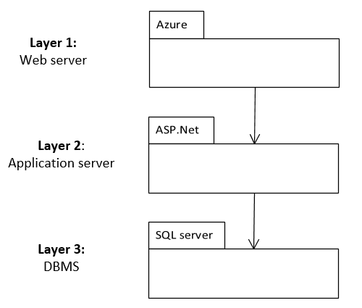

## System and Subsystem Decomposition

The system was built using MVC architecture as represented below:

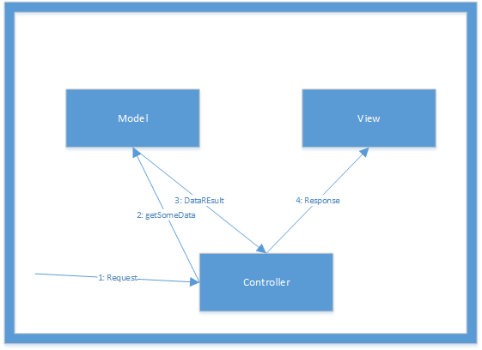

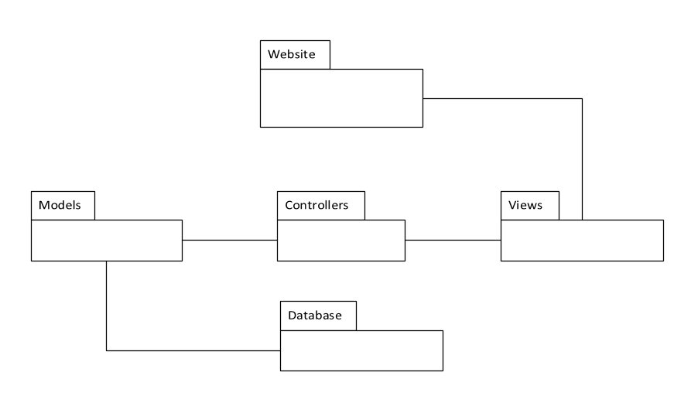

## Class Diagram

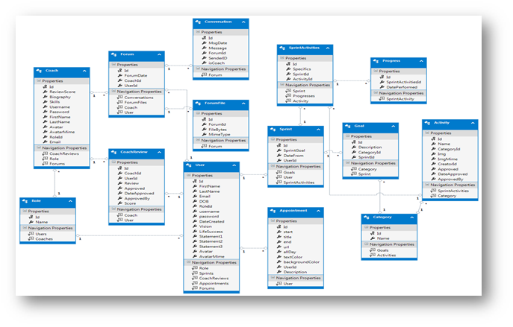

## 

# System Validation

Unit testing was performed for each user story after completion. The tests consisted in both white and black boxes. For automated tests we used Microsoft Edge with the Microsoft WebDriver tool. Integration tests were also performed throughout all the development cycle. We also performed several usability tests, by having friends and professionals to use the system, in order to detect possible downfalls, and gain more insight of how user-friendly or intuitive our system was. The owner, had also validated the product during each of our bi-weekly meeting, where we either demo our progress, or have himself to use the site.

# 

# 

# 

# Glossary

# 

# 

# Appendix

## Appendix A - UML Diagrams

**Static UML Diagrams:**

* Use Case Diagram

# 

**Dynamic UML Diagrams (Not all diagrams are included):**

For a complete list refer to the detailed documentation by Sprints (<https://drive.google.com/drive/u/0/folders/0B457zg45quzrbjJYN1NFcHdlc2s>).

* **User Story Name:** Main Page

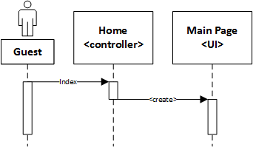

* **User Story Name:** Sign Up

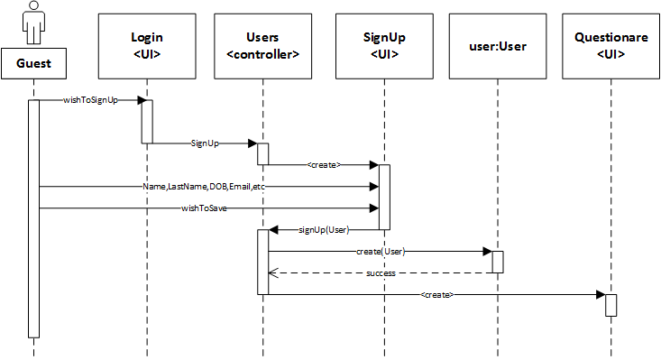

* **User Story Name:** Login

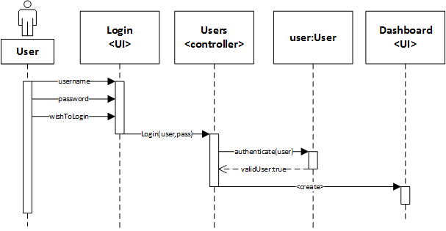

* **User Story Name:** Reset Password
* Part 1

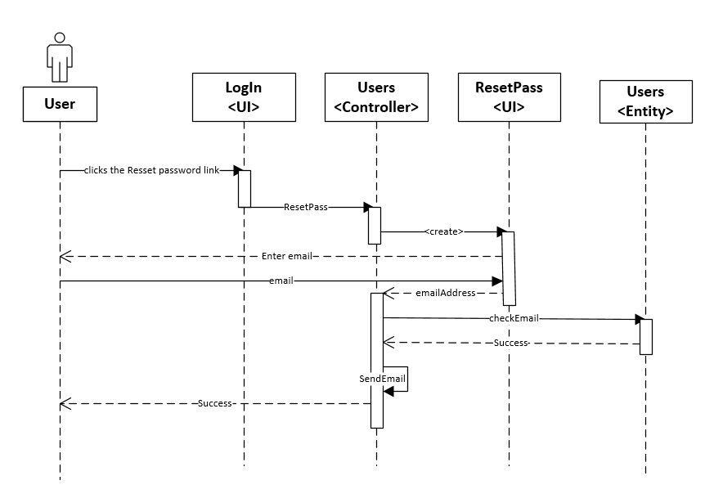

* Part 2

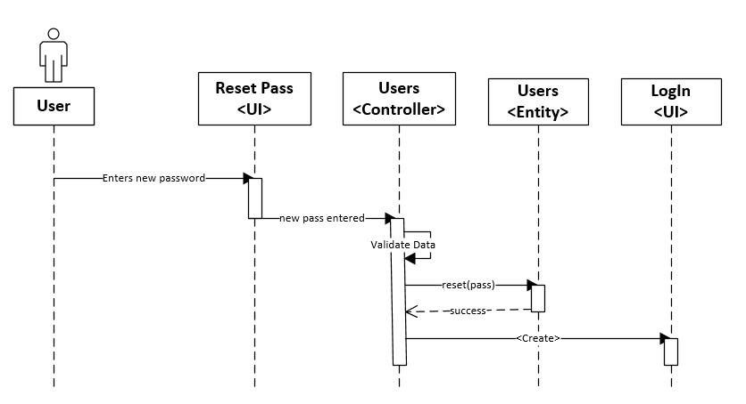

* **User Story Name:** Collect Joy

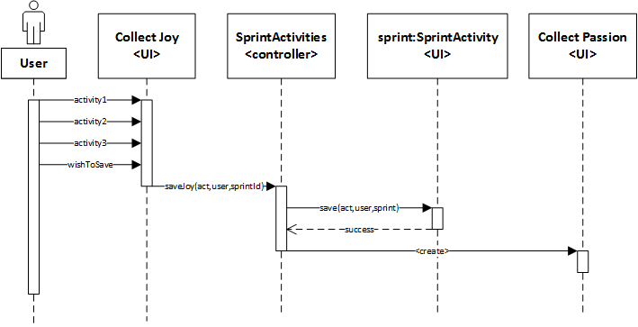

* **User Story Name:** SeeDashboard Page Joy Tab

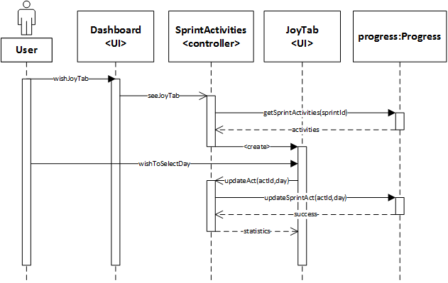

* **User Story Name:** Add a life Coach

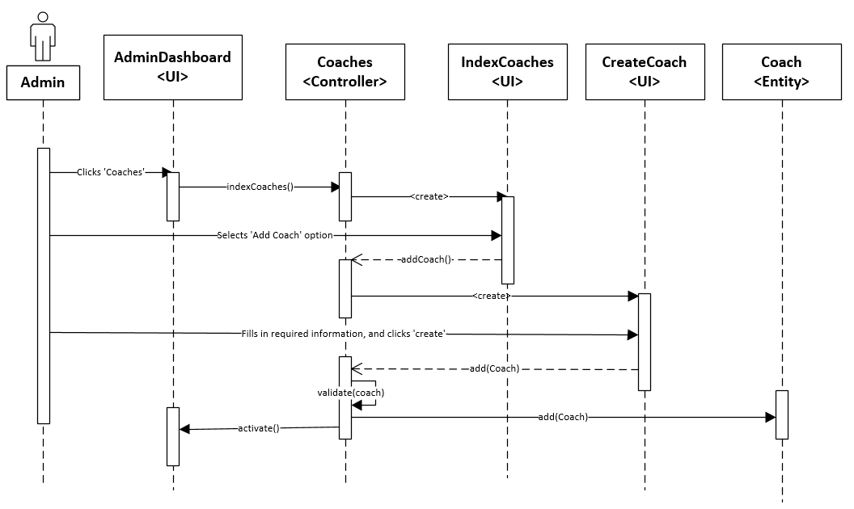

* **User Story Name:** Create an Activity

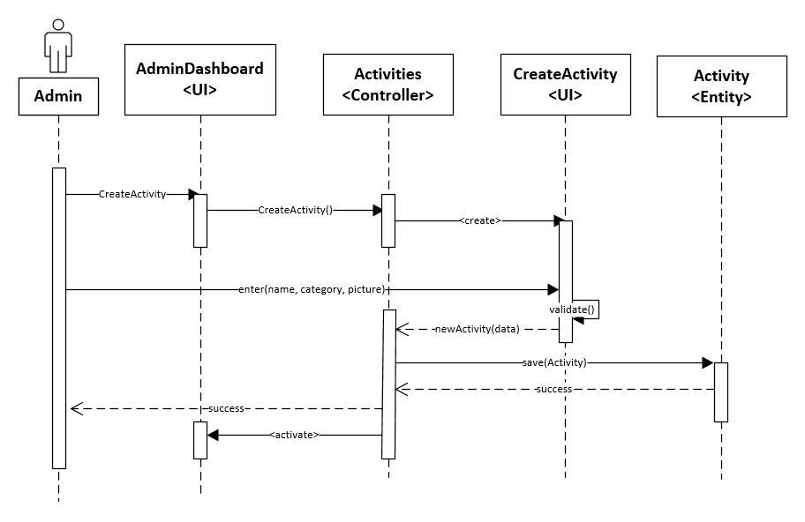

* **User Story Name:** New Sprint Setup

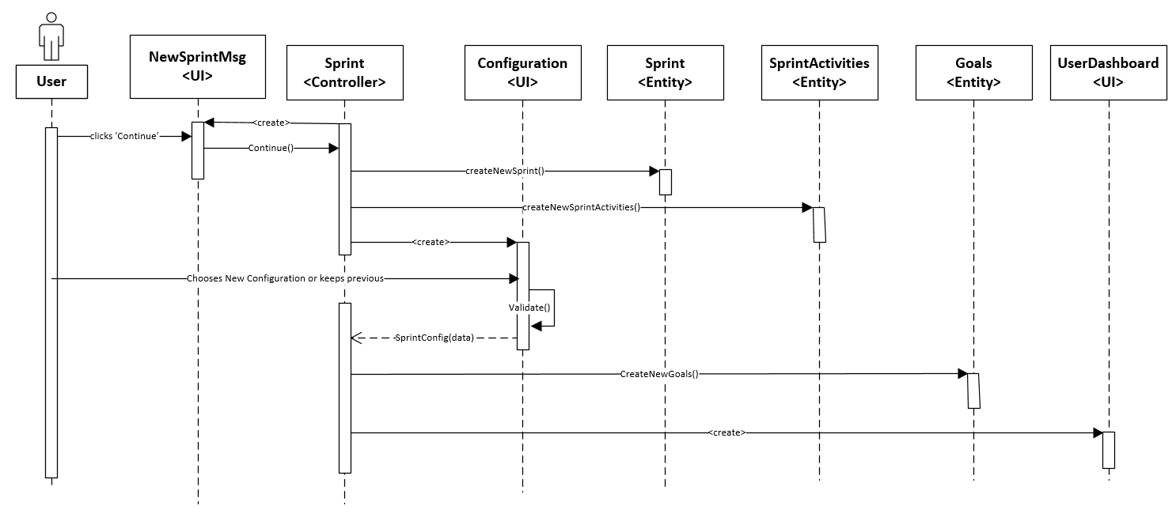

* **User Story Name:** Share Progress

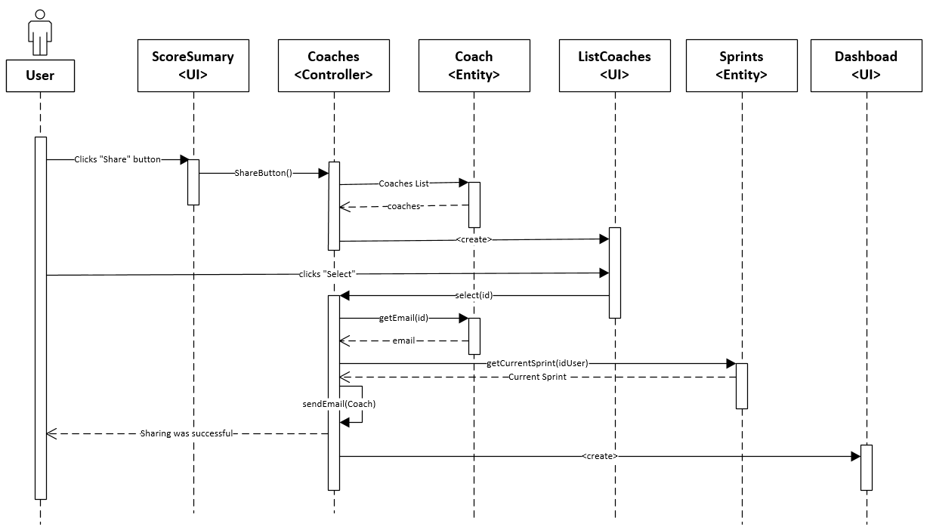

* **User Story Name:** See Life Coaches

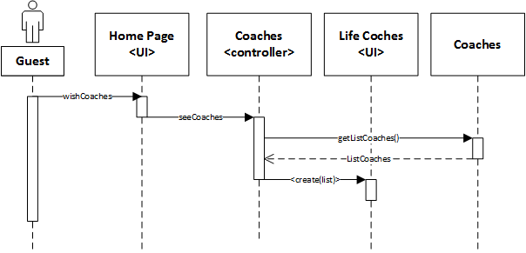

* **User Story Name:** Communicate With Life Coach

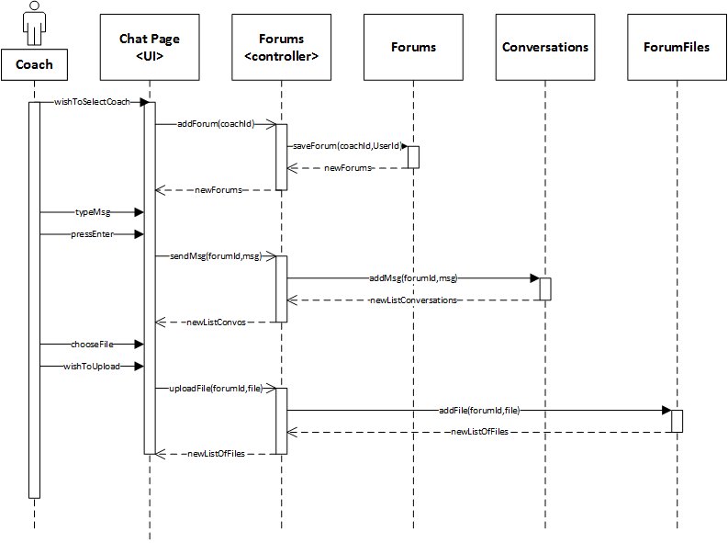

* **User Story Name:** Review Coach

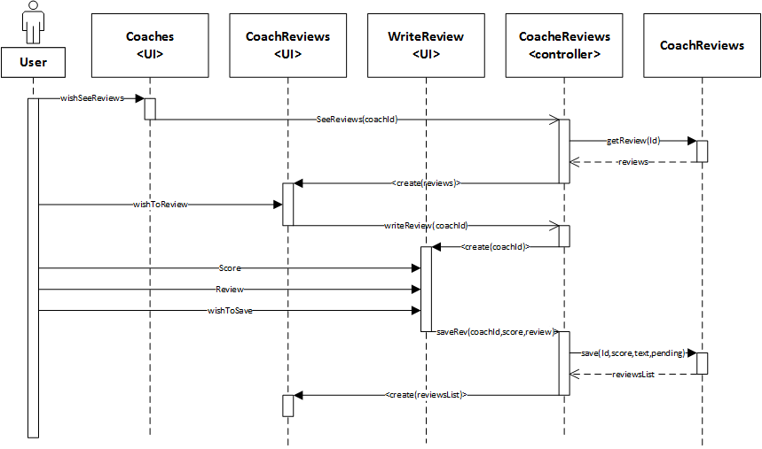

* **User Story Name:** Check Coach Review

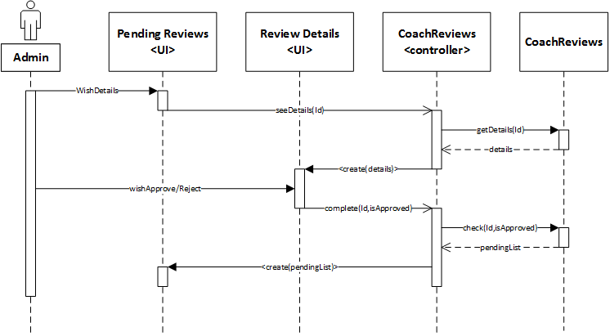

* **User Story Name:** Manage Account

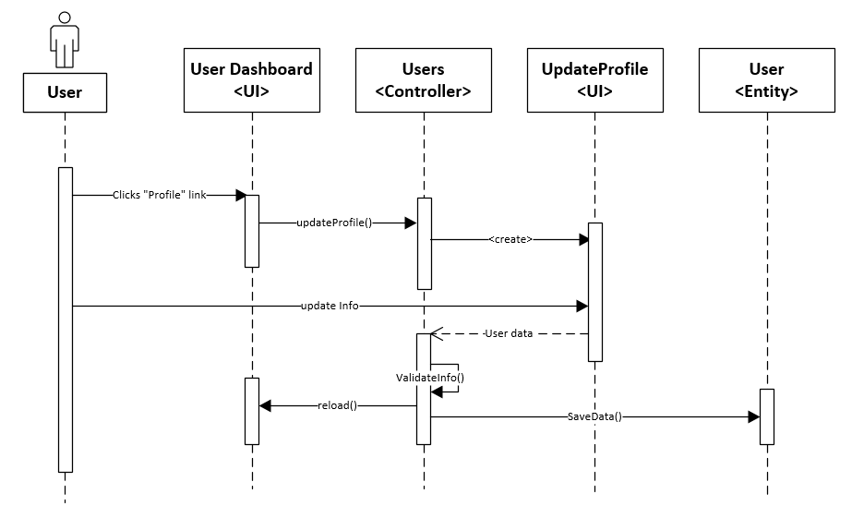

## 

## Appendix B - Sprint Review Reports

**Sprint # 1:**

**Sprint Review Meeting Minutes**

Attendees: Beatriz Hernandez, Fernando Mojena Amaya, Ranjeet Deshmukh, Ravi Kiran Agarthi

Start time:7:30

End time: 7:45

After a show and tell presentation, the implementation of the following user stories were accepted by the product owners:

|  |  |
| --- | --- |
| 671 | Collect Joy |
| 693 | Setting up a Vision goal |
| 672 | Collect giving back |
| 670 | Collect passion |
| 669 | Reset password |
| 668 | Login |
| 667 | Sign up |
| 687 | Site Admin Dashboard |
| 686 | Login Page |
| 675 | Dashboard Page-Create |
| 673 | Main Page |
| 704 | Setup Sprint |

The following ones were rejected and moved back to the product backlog to be assigned to a future sprint at a future Spring Planning meeting: none

**Sprint # 2:**

**Sprint Review Meeting Minutes**

Attendees: Beatriz Hernandez, Fernando Mojena Amaya, Ranjeet Deshmukh, Ravi Kiran Agarthi

Start time: 7:00 pm

End time: 7:20 pm

After a show and tell presentation, the implementation of the following user stories were accepted by the product owners: All.

|  |  |
| --- | --- |
| 674 | Dashboard Page-Joy Tab |
| 676 | Dashboard Page-Passion Tab |
| 677 | Dashboard Page-Giving Back Tab |
| 681 | Add Life Coach |
| 683 | Score Summary Page |
| 712 | Create activity |
| 727 | Edit Life Coach |
| 728 | Remove Life Coach |
| 726 | Edit Activity |
| 725 | New Sprint Setup |

The following ones were rejected and moved back to the product backlog to be assigned to a future sprint at a future Spring Planning meeting. No story was rejected.

**Sprint # 3:**

**06/29/2017 Sprint Review Meeting Minutes**

Attendees: Beatriz Hernandez, Fernando Mojena Amaya, Ranjeet Deshmukh, Ravi Kiran Agarthi

Start time: 7:00 pm

End time: 7:20 pm

After a show and tell presentation, the implementation of the following user stories were accepted by the product owners: All.

|  |  |
| --- | --- |
| 678 | Share Progress |
| 734 | Communicate with coach ( forum ) |
| 679 | See Life Coaches |
| 680 | Select Life Coach |
| 684 | Life Coach Details Page |
| 731 | Coaches Login |
| 733 | Coach Dashboard |
| 732 | Reset password for Coaches |
| 678 | Share Progress |
| 734 | Communicate with coach ( forum ) |

The following ones were rejected and moved back to the product backlog to be assigned to a future sprint at a future Spring Planning meeting. No story was rejected.

**Sprint # 4:**

**07/10/2017 Sprint Review Meeting Minutes**

Attendees: Beatriz Hernandez, Fernando Mojena Amaya, Ranjeet Deshmukh, Ravi Kiran Agarthi

Start time: 11:00 am

End time: 11:20 am

After a show and tell presentation, the implementation of the following user stories were accepted by the product owners: All.

|  |  |  |
| --- | --- | --- |
| 750 | Add activity | 8 |
| 691 | Review Coach | 4 |
| 692 | Check Coach Review | 16 |
| 685 | Manage Account | 4 |
| 688 | Create Crud for Roles | 4 |
| 689 | Create Crud for Activities | 4 |
| 690 | Create Crud for Users | 4 |
| 682 | Invite to app | 2 |
| 751 | Take coaching quiz | 4 |

The following ones were rejected and moved back to the product backlog to be assigned to a future sprint at a future Spring Planning meeting. No story was rejected.

## Appendix C - User Manuals, Installation/Maintenance Document, Shortcomings/Wishlist Document and other documents

**Life Management 1.0**

**User Manual**

**Authors: Beatriz Hernandez**

**Fernando Mojena**

Table of Contents

Users 56

Create Account 56

Change profile 59

Dashboard 60

Share Progress 62

Guest 62

Quiz 62

List of Coaches 63

Coaches 66

Login 66

Manage Profile 67

Chat 67

See User’s progress 68

Site Administrator Guide 69

Login 69

Create an Activity 71

Edit Activity 72

Delete Activity 74

Add a Life Coach 76

Approving Pending Activities 77

## Users

### Create Account

1- Click User Login link

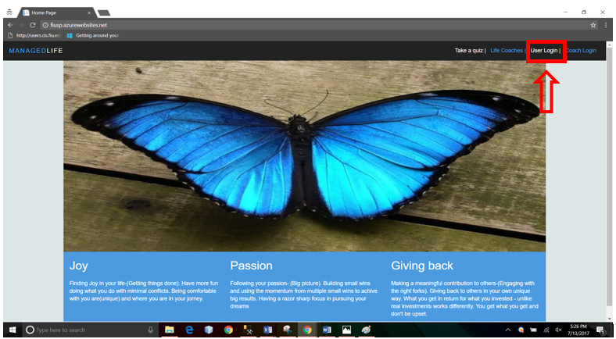

2- Click create Account

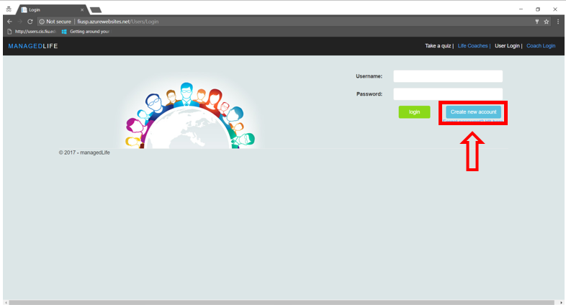

3- Fill out all fields and click save

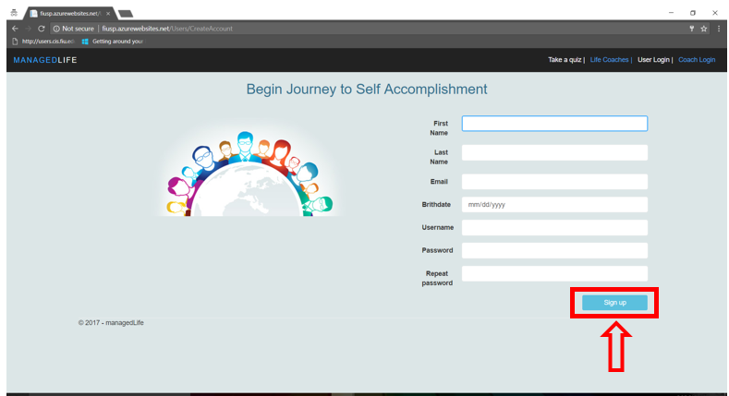

4- Complete initial questionnaire, click continue

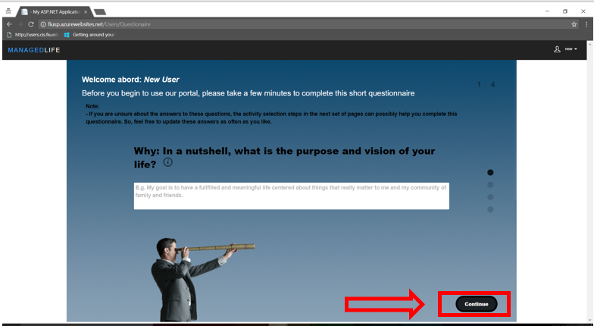

5- Click + button, and Choose 3 options here:

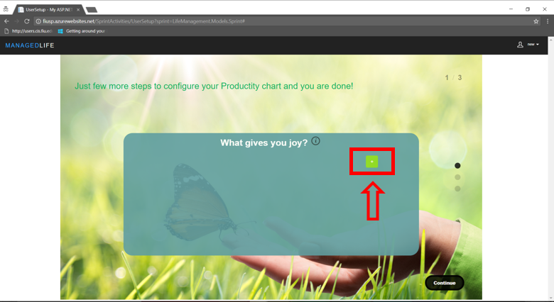

6- Select two options in the following 2 screens

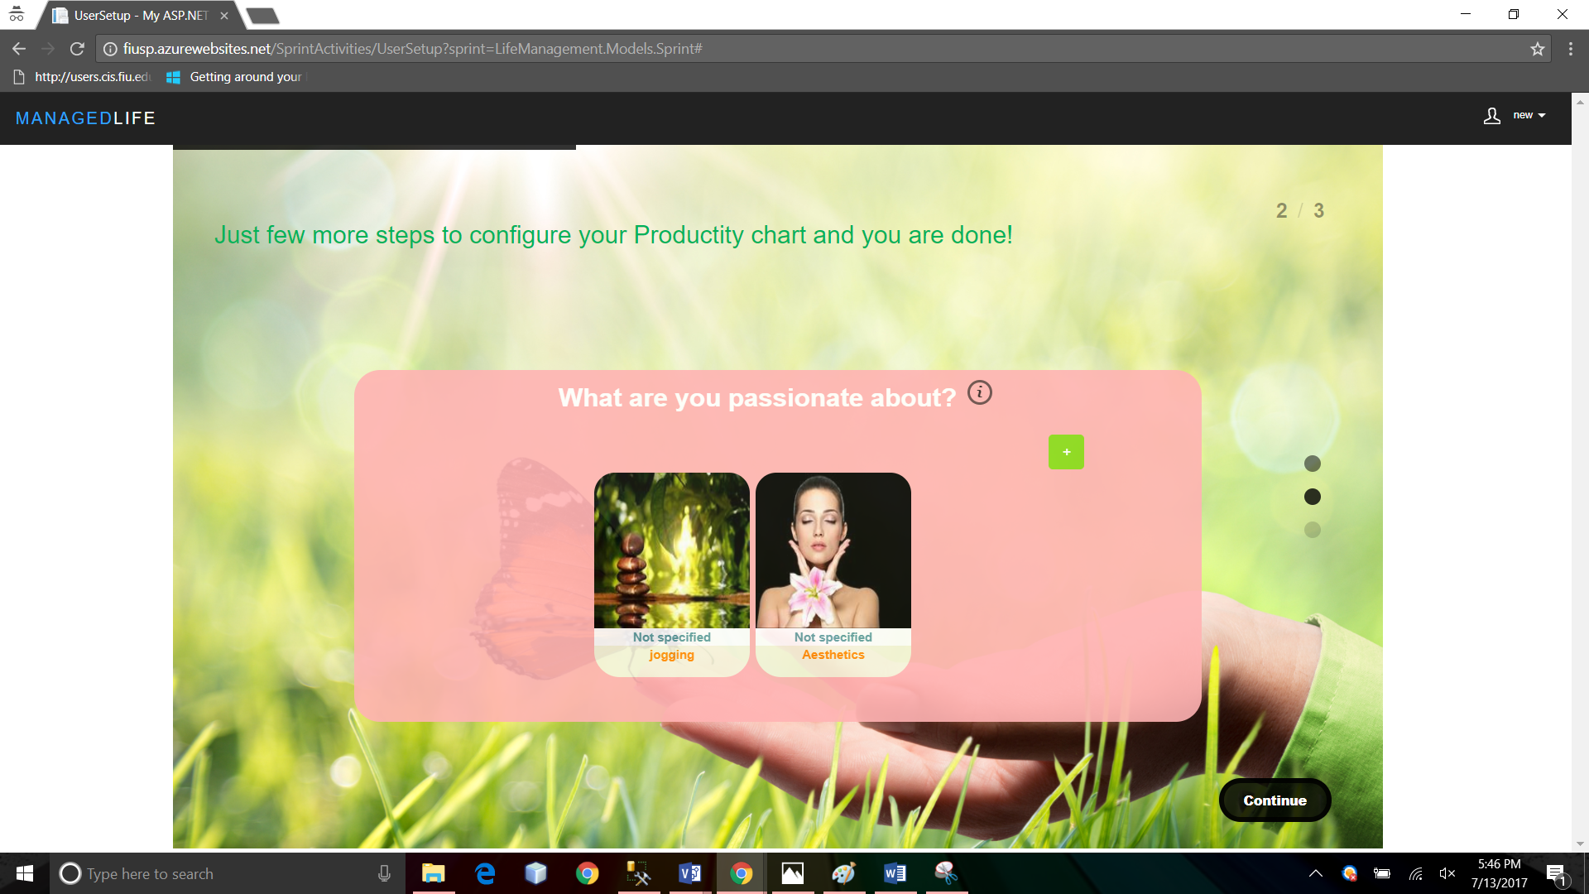

7- After configuring all your account, you’ll see your dashboard.

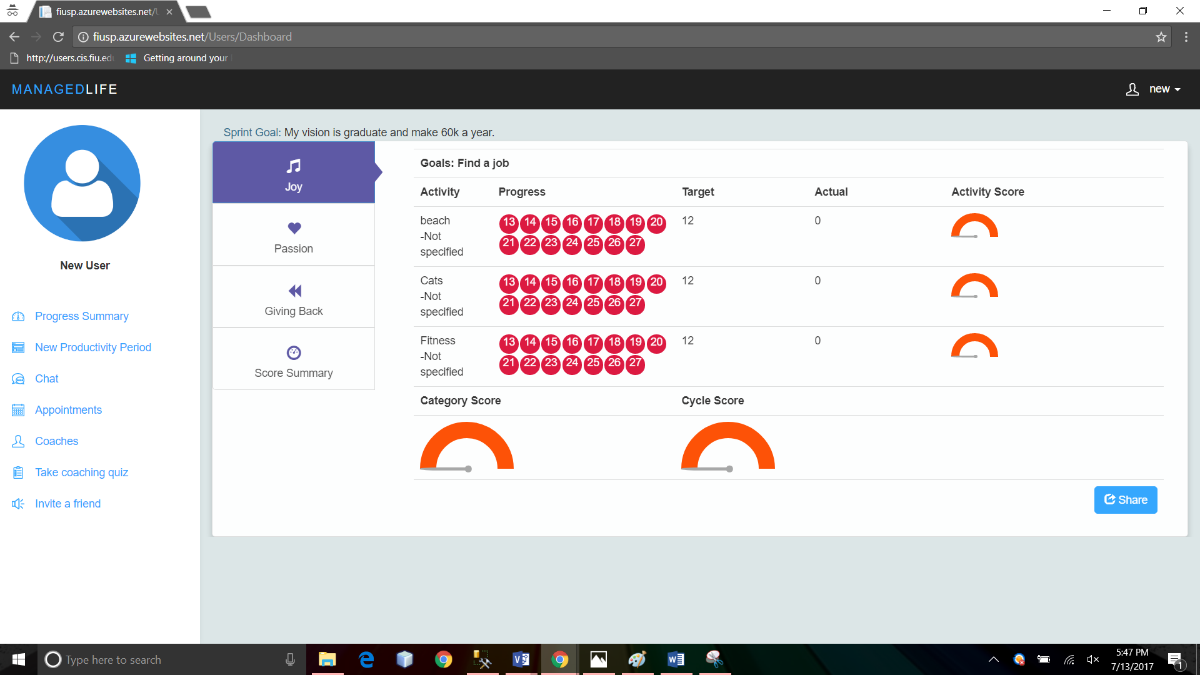

### Change profile

1- To change your personal information, click the profile link

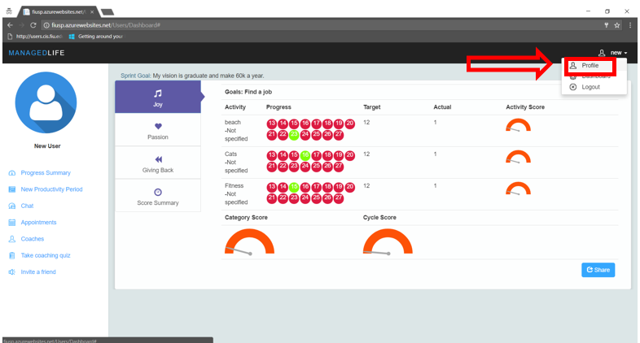

### Dashboard

- The panel on the left from top to bottom:

Progress summary: That is the home dashboard page, in the tabs to the right to can click on the calendar a day where you perform the corresponding activity. The circle representing the day, will turn green once selected. You can click any tab “Passion”, “Give Back” and “Score summary” to either register certain activity, or to check your progress.

New Productivity period: Use this link when you are not satisfied with your selected activities and want to start a new period.

Chat: Use this link to chat with your coaches and share files with them. (See picture below)

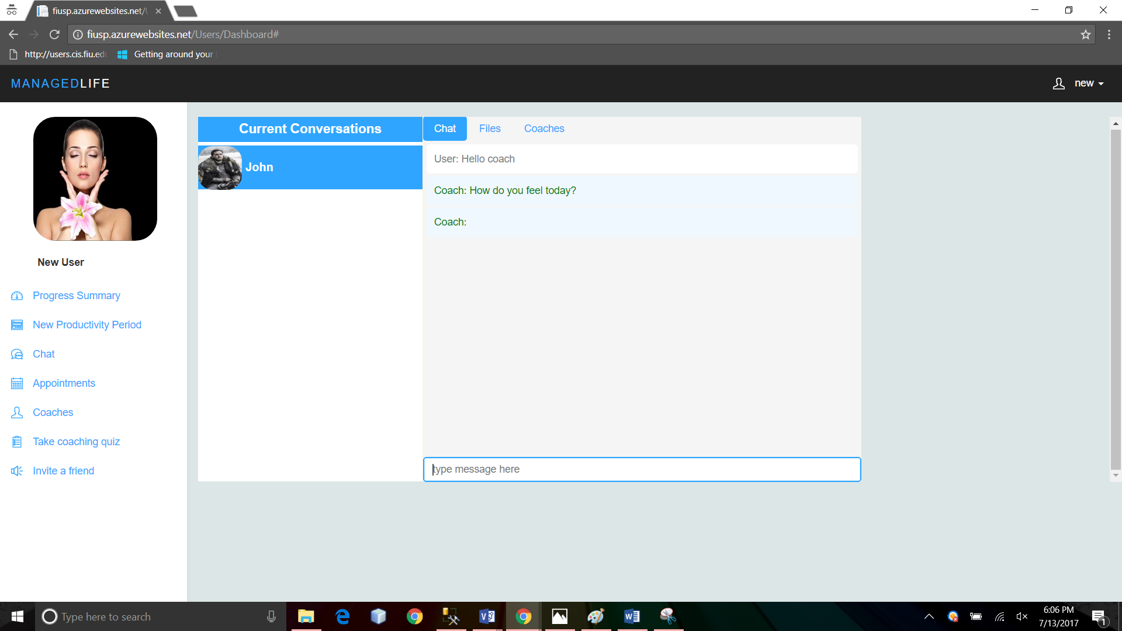

Appointments: Use this feature to schedule an appointment. (See picture below)

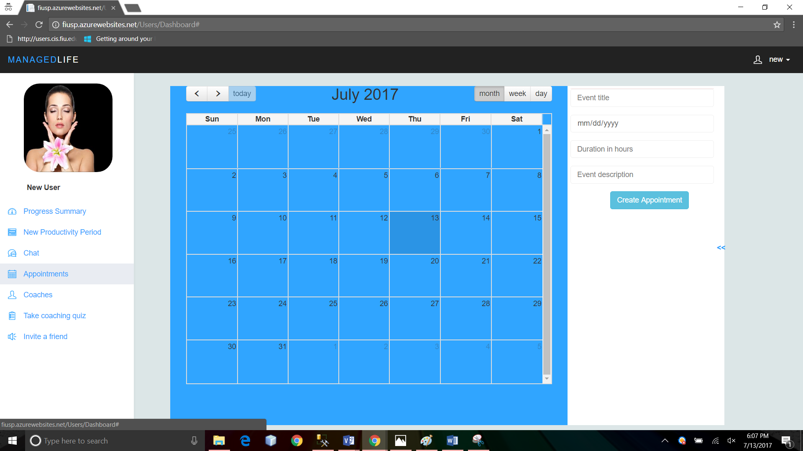

Coaches: There you can see a list of all available coaches in the system.

Take Coaching Quiz: Use this link to take a 12 question quiz, and find out whether you need a life coach in your life or not.

Invite a friend: Use this link to invite a friend to the application. The friend will receive an email with a link to the sign-up page.

### Share Progress

To share your progress in a certain category, or a summary of all of them, you can always click the share button, in the right bottom part of each tab, and follow instructions.(See screenshot). The coach will receive a copy of your progress in that category.

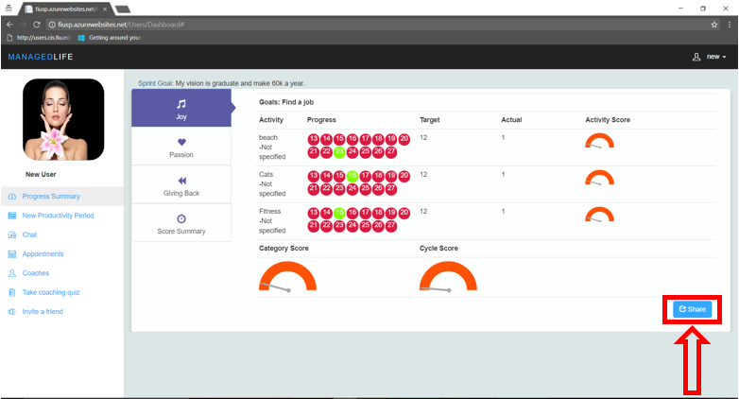

## Guest

### Quiz

1. Take the coaching quiz: Click the “Take a Quiz” link to take a 12 question quiz, and find out whether you need a life coach in your life or not. (#1 in screenshot below)

### List of Coaches

1. See list of available coaches: Click the “Life coaches” link, and a list of coaches with their personal information will appears. Quests are able also to see coaches reviews. (#2 in screenshot below)

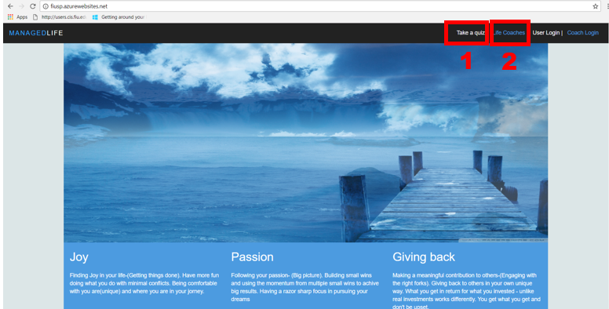

Take quiz Interface:

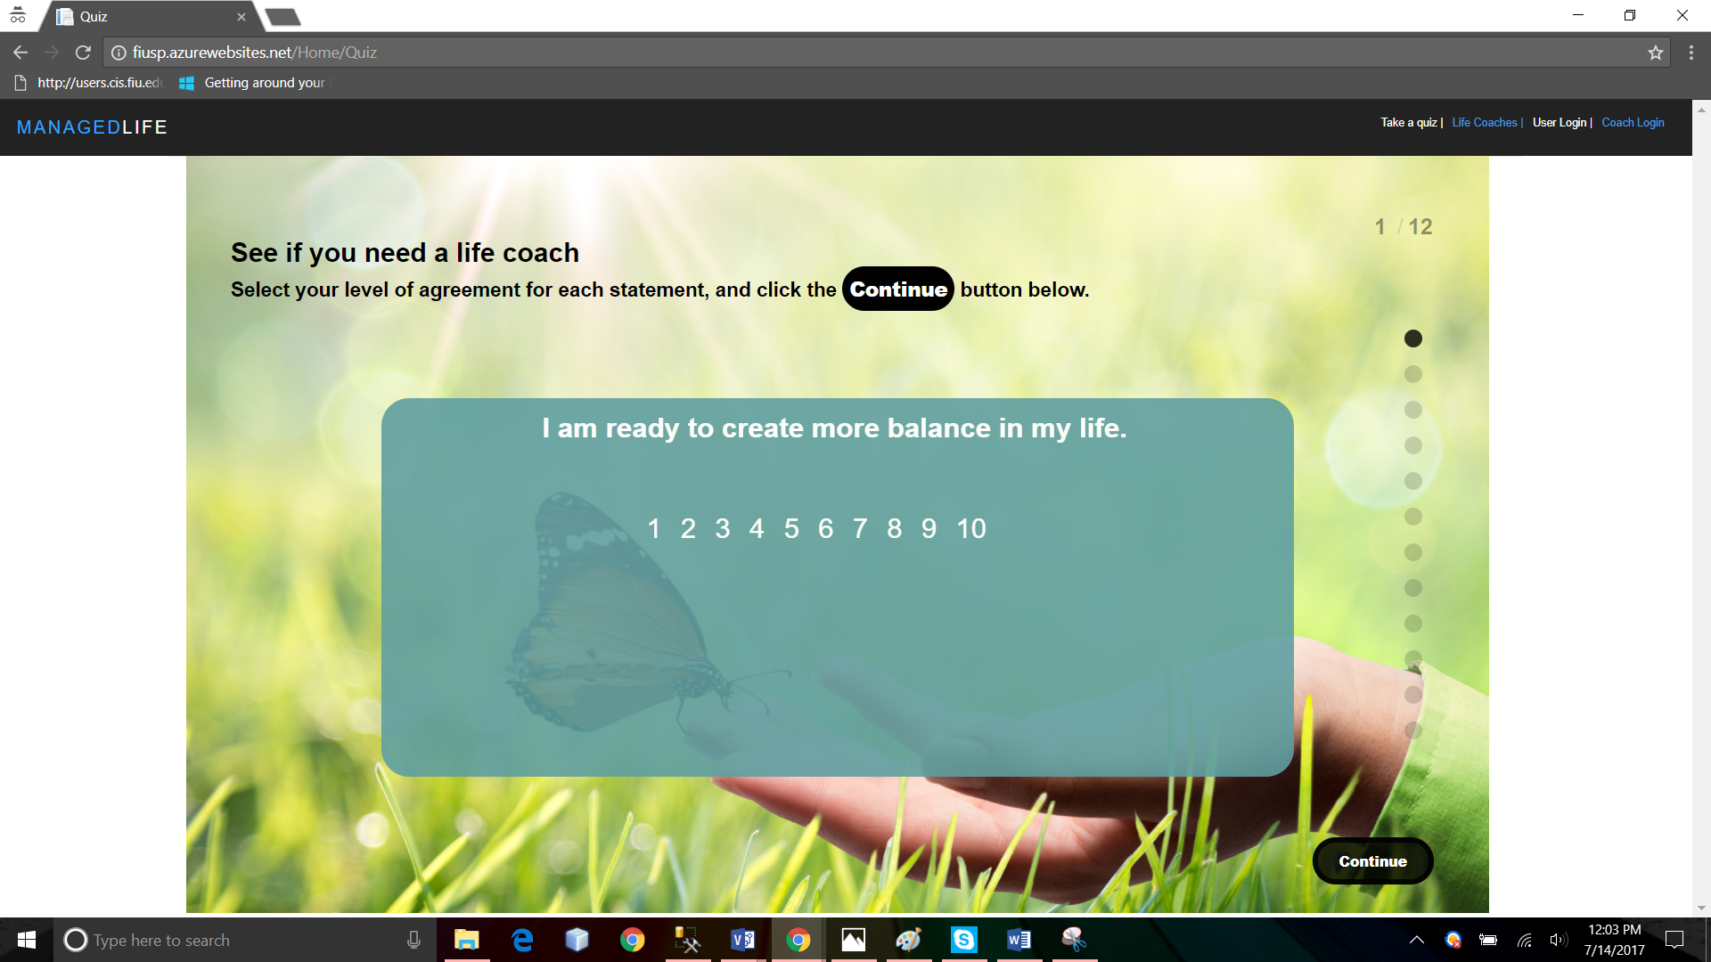

List of Coaches Interface:

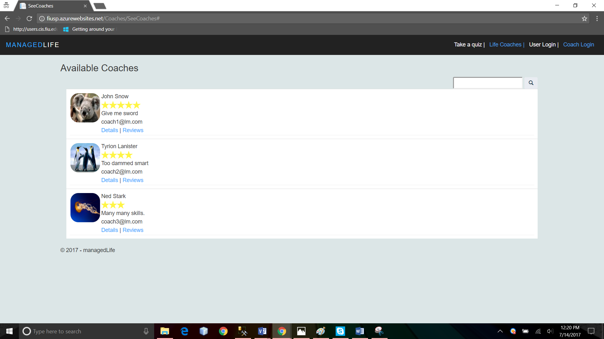

## 

## Coaches

### Login

1. Coaches can login using the “Coach Login” Link in the Main Page.

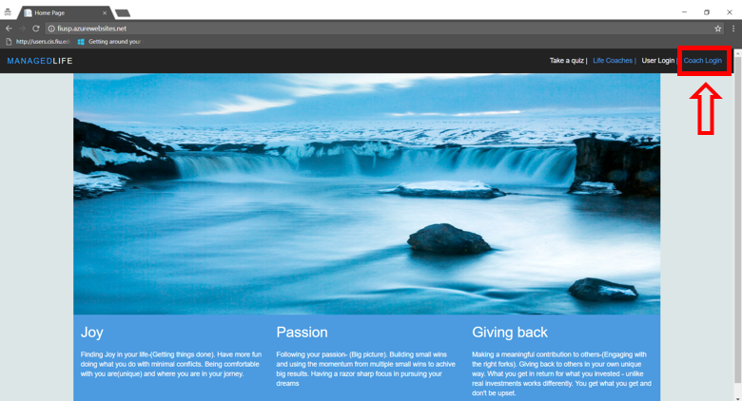

2- Login page: Coaches should enter the credentials provided by the site Admin who add them to the system.

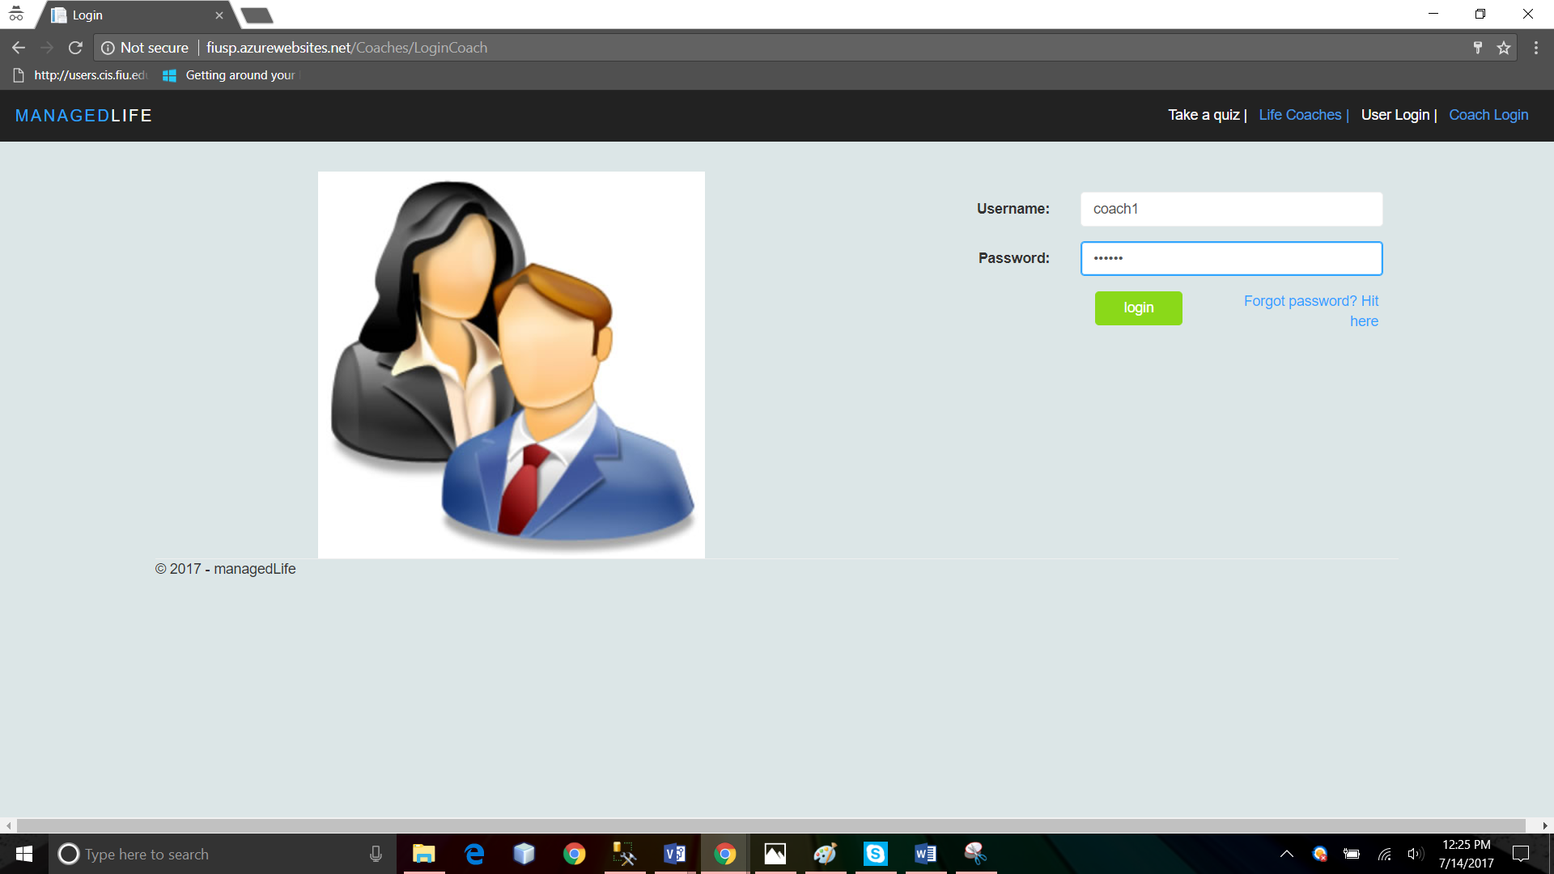

### Manage Profile

Same as User.( Refer to User Manual Above).

### Chat

From their dashboard, Coaches can chat with users, at users request.

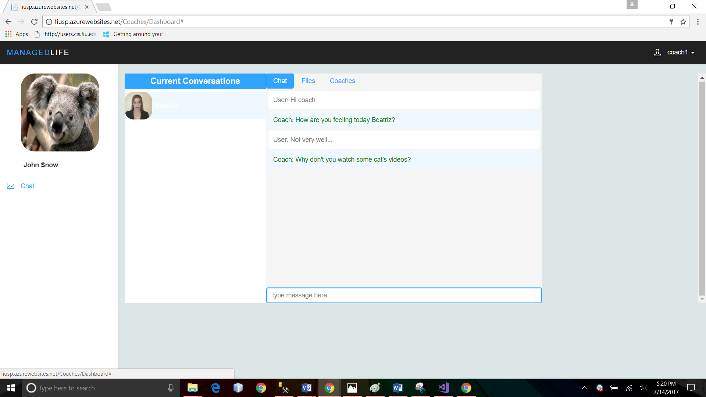

### See User’s progress

Coaches are able to see a live copy of the User’s progress for the period, at user’s request.

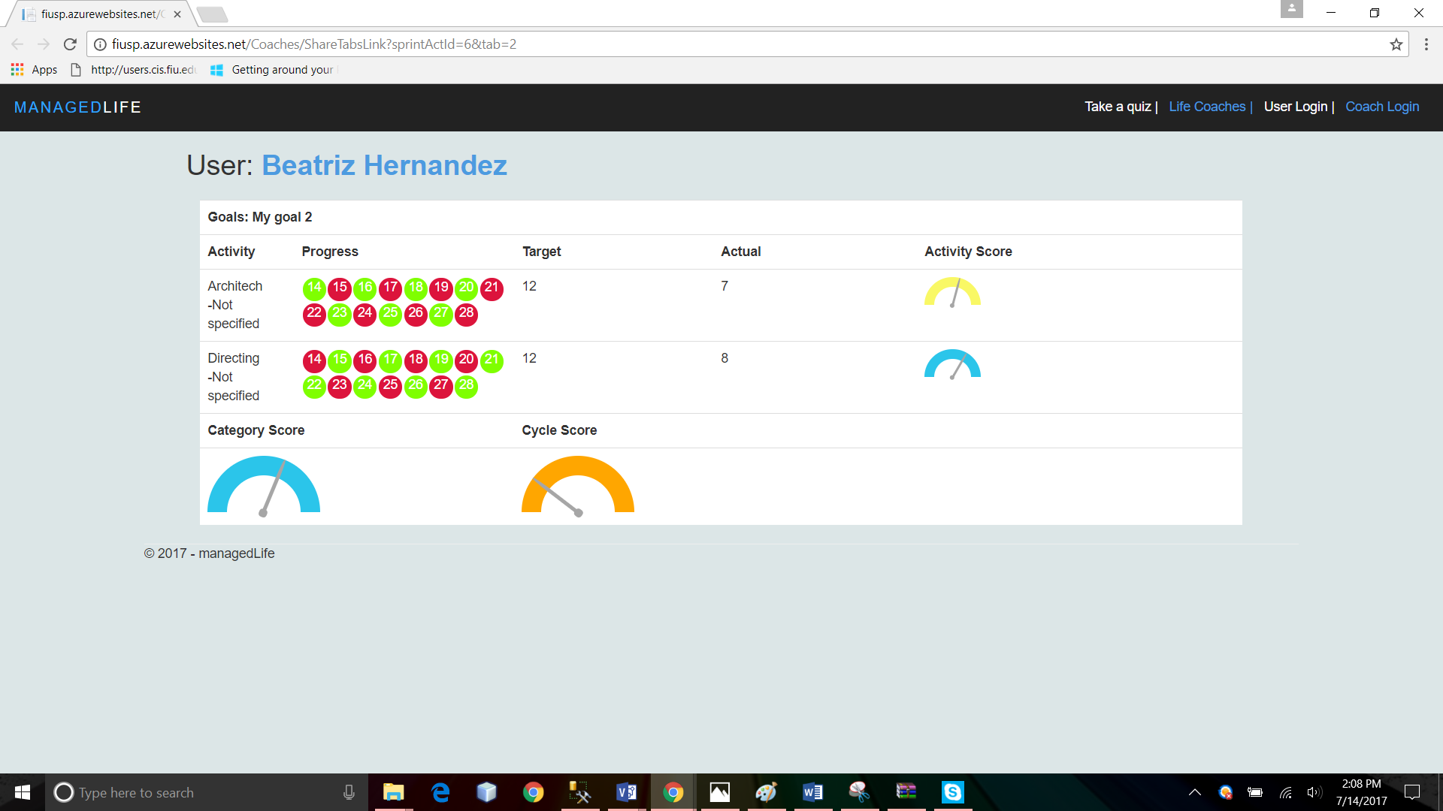

## Site Administrator Guide

### Login

As a site administrator,

1- Navigate to the website url: “fiusp.azurewebsites.net”

2- Click “User Login”

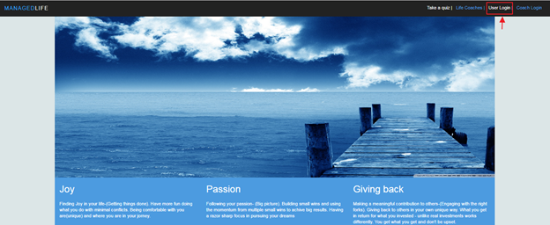

3- In the login page, enter your admin credentials and click “Login”

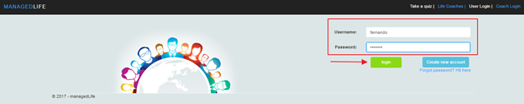4- The admin dashboard is presented

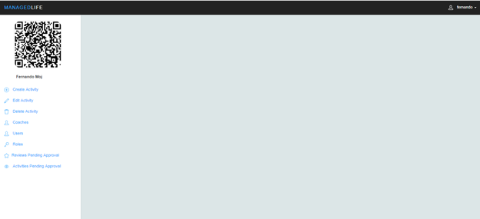

### Create an Activity

1- In the administrator dashboard, click “Create Activity” in the left navigation panel

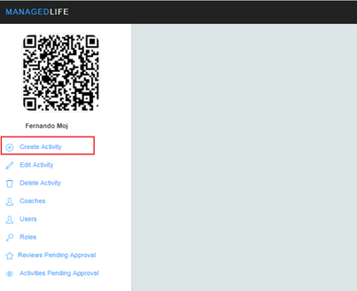

2- Provide name, category and browse your PC for an image, then click “Create”

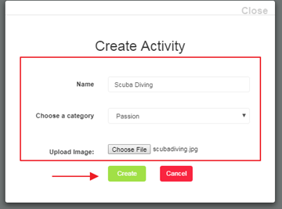

3- Confirmation is displayed

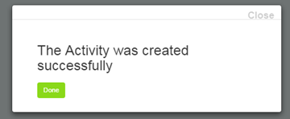

### Edit Activity

To edit an existing activity,

1- click the “Edit” link the left navigation panel

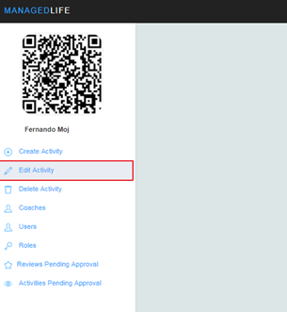

2- In the popup window, select the desired category and then click the activity to be edited:

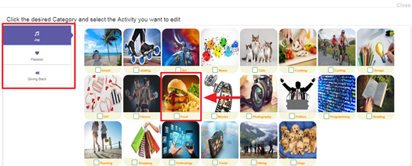

3- Update the desired information and click save

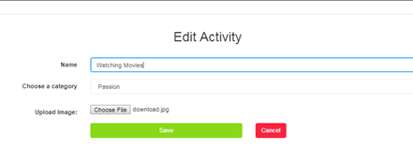

4- Confirmation is displayed

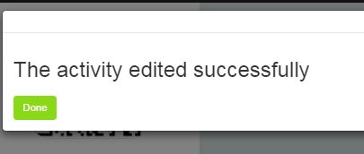

### Delete Activity

To delete an existing activity,

1- Click the “Delete Activity” link in the left navigation panel

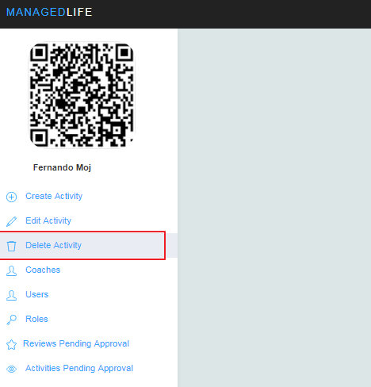

2- Select the category and activity you wish to delete

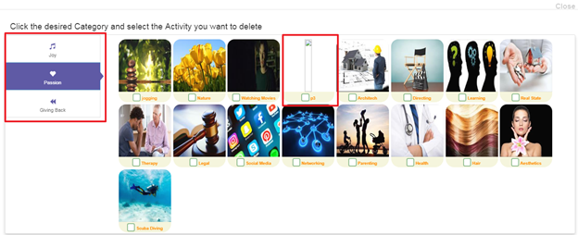

3- Confirm deletion

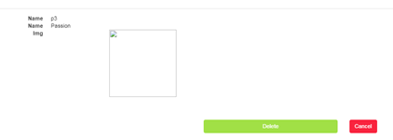

4- Success message appears:

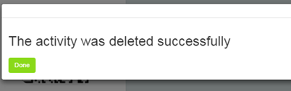

### Add a Life Coach

To add a coach,

1- Click the coach link in the left menu and then the “Add New” button

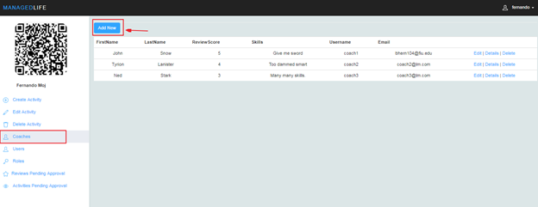

2- Provide information requested and click “Create”

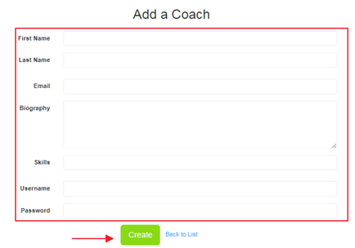

### Approving Pending Activities

To approve and make available to everyone user created activities

1- click the “Activities Pending Approval” link the left menu

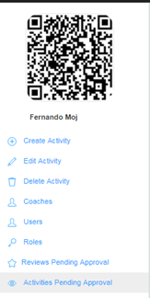

2- Click a pending activity in the list

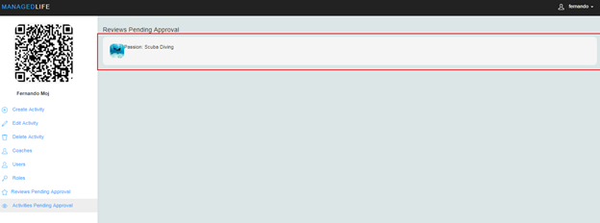

3- Click approve or reject on the popup window

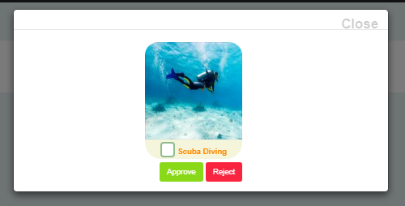

# Installation Manual

For the installation, the following is required

Either IIS or a Web App in Azure

SQL Server version 2012 or later.

Visual Studio 2015 or later version.

First open SQL Server and execute the script located in Code/Database folder named DBCreationScript.sql. That will create the database and insert some data.

Then, open the solution file located in Code/Website folder named LifeManagement.sln. Use Visual Studio 2015 for this. Make sure you modify the connection string in

the configuration file Web.config to point to the appropriate database:

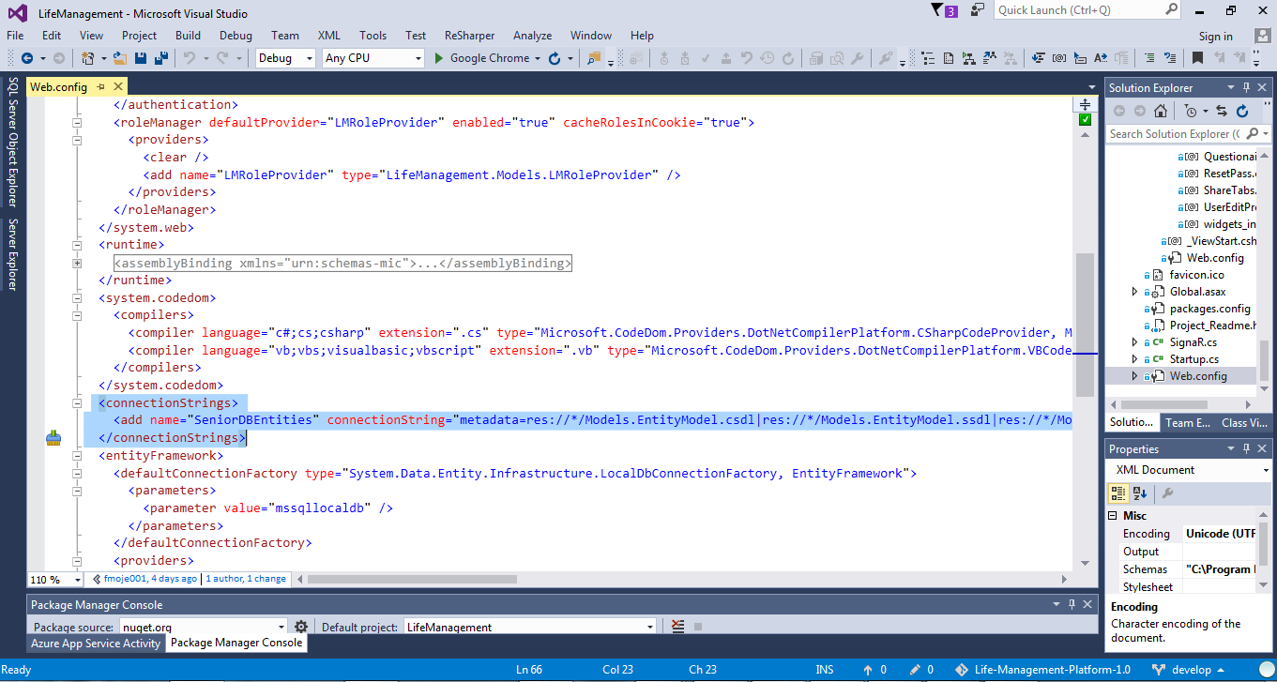

Also, Make sure everything is working properly by rebuilding and running the solution. To build it select the project file in the Solution Explorer and click the Build menu, then rebuild solution:

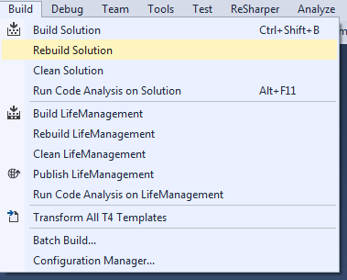

If any error comes up, it needs to be fixed before continuing to next step.

Once the solution is built, run it by pressing f5 or using the Debug menu, start debugging:

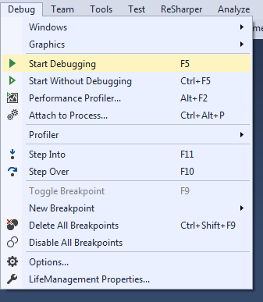

Make sure everything is working properly, if so, stop debugging in the debug menu and you are ready to publish your solution.

As of now, we are hosting the web application and database in azure but it can also be hosted in a local IIS. If you wish to do so, please refer to user guides on how to install and setup IIS for .Net framework 4.5.2.

To publish the solution, select the project file and click the Build menu and then publish Life Management.

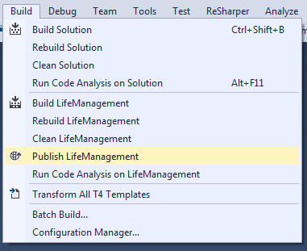

In the Profile section you are offered to create a new profile with appropriate parameters.

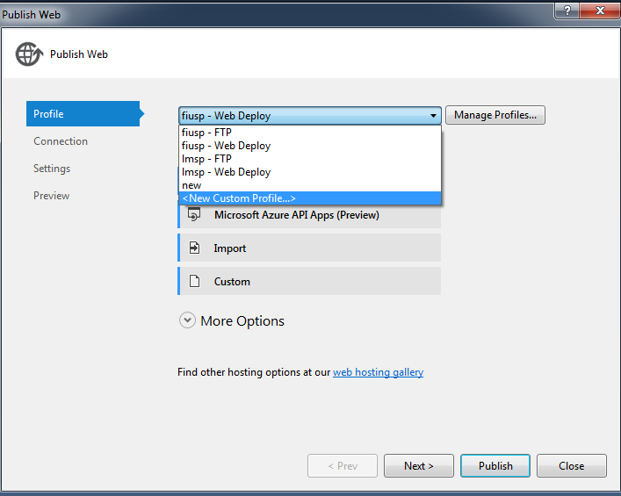

That is, you may use web deploy, ftp or file system. Each of these options have specific parameters that need to be in place before proceeding.

Click next and update information as needed and click publish once you have the option available.

**Maintenance Manual**

We recommend to use git source control in the following manner.

In the Team explorer, make sure you are in the home screen by clicking the home icon. then click branches.

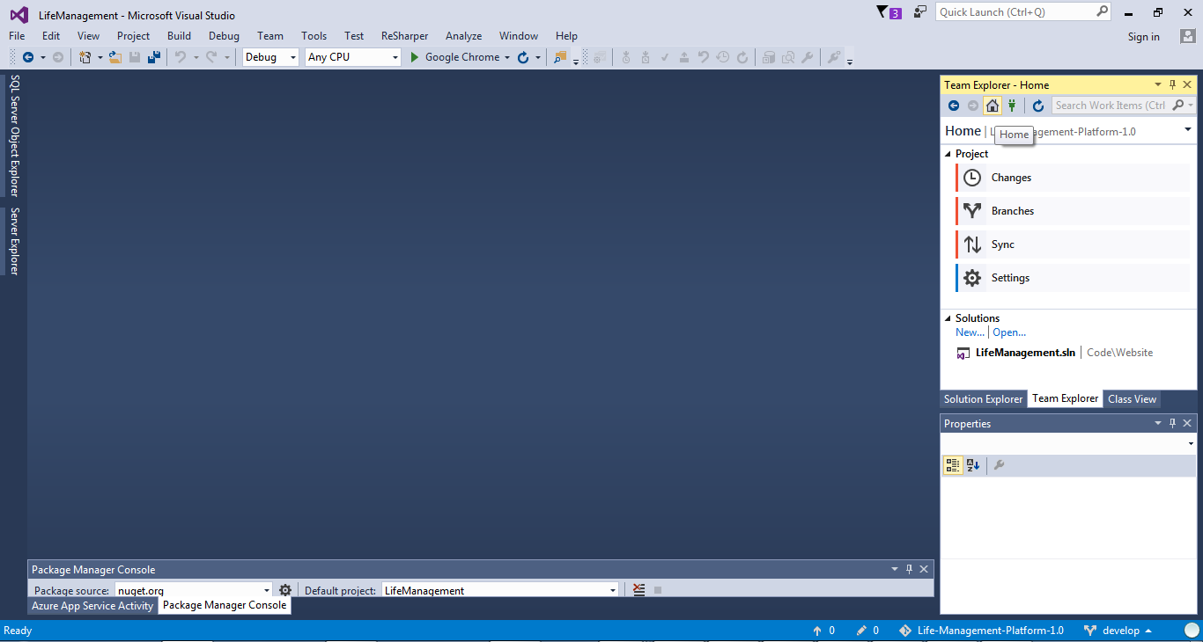

Right click Life-Management-Platform-1.0 and then "Open command prompt". This tutorial assumes you have git installed.

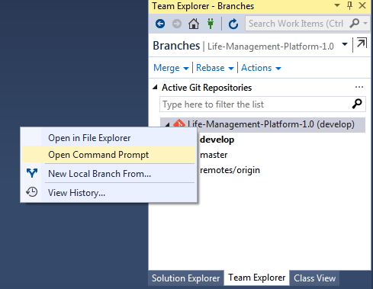

If you need to add code or any other modification

1- Create a new branch from develop using the command **"git checkout -b <nameofyourbranch> develop"** and press enter

2- Go to visual studio and work on your modifications. when done, go back the command prompt and execute **"git add -A"** to add or delete files

3- Then **"git commit -m "explanatory message about changes"**

4- Change to develop using **"checkout develop"**

5- Merge it with the new branch using the command **"git merge --no-ff <nameofyourbranch>"**

6- Pull the source control server files using "**git pull"** from develop and resolve any conflicts that may appear.

7- Then push the new version of your develop to the server using **"git push"**

8- Delete the branch using **"git branch -d <nameofyourbranch>"**

After this, publish your changes using the steps previously explained.

**Shortcomings and Wishlist**

Our website fails to present a clear purpose and usage to a first time user. For that reason, it is intended that next versions address this by enhancing the user interface with more explanations and hints.

It is the view of the product owner and team members that the questionnaire for user initial setup has too many questions that are somehow difficult to answer. This has caused many users to feel frustrated when creating an account and for ease of use purposes, we wish that next versions take care of this by rephrasing or removing some of the questions.

We also feel that the Chat can be improved so as to make it more intuitive for regular users. Hence, front end design of the conversations should be enhanced.

Another functionality that should be added is giving a site administrator the ability to add more site administrators. This we do not consider a shortcoming as it was not in our requirements but it is definitely in our wishlist.

Finally, there is a need for a module that will be used by life coaches to register in the website and be granted the role of coach by a site administrator. These coaches need to pay a monthly subscription fee so as to remain active in the list of available coaches. Although this module was not part of our product backlog, the product owner has mentioned his intentions to include it.

# 

# References

1. ASP.NET MVC Overview. N.p., n.d. Web. 13 July 2017. <https://msdn.microsoft.com/en-us/library/dd381412(v=vs.108).aspx>.
2. Bruegge, Bernd . "Design Goals & System Decomposition." PDF. Web. 13 July 2017.
3. Tips and guidelines provided in Moodle.